CHIPPING SODBURY RAPIDPLAY 13th OCT. 2012

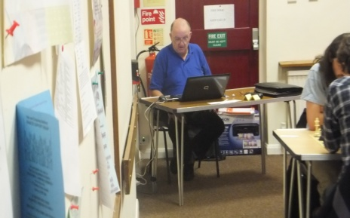
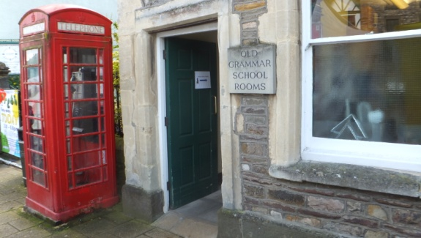
There were several causes for celebration at this event. I’d worked out it was the 20th one since they started in 2003, we’d moved across the road to a new venue, Geoff Gammon had volunteered to arbit so I could play, and Geoff was using a computer pairing system, either Swiss Master or Swiss Perfect, I can’t remember which. Geoff was slightly nervous, this being the first time he’d run an event using the system, but it all went swimmingly. There was a slight problem with the printer at one stage, but it conveniently happened during the lunch time break, so no one noticed.
There were 34 players present, in two sections. It was supposed to be 3, but only 4 players had entered the Minor, so they had to be incorporated into the Major. I found out the day before that this was the day of the ECF AGM, so perhaps they’d all gone there. Sadly, there were 17 in each section, so there had to be byes. A fairly strong contingent arrived (eventually) from the university, as well as 3 from Wales.
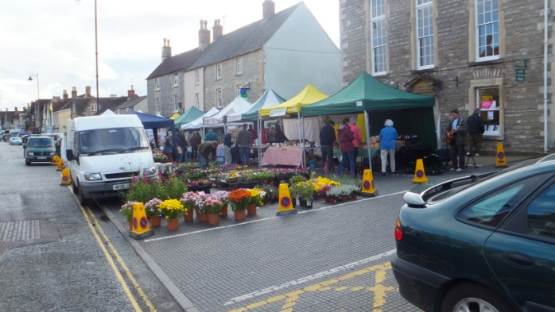
Outside, (just outside!) there was a farmers market, which I hadn’t known about beforehand, but despite this, everyone found the venue without a problem. The market also featured a guitarist (right of picture by the window), but it’s not known whether he was a farmer.

In the Open section, top seed James Cobb dropped only half a point to second seed Henry Duncanson. Henry was half a point behind James, but lost in the last round to Chris Russell of the University, who finished in second place with 4½. The grading prize was shared by EM White, Andy Gregory and Craig Kennedy, all on 3.
In the Major, things were somewhat closer, and going into the last round there was the possibility of 3 players finishing joint first. However, in the end Daniel Young(University) defied his grade of 120 to finish with 6/6. Tom Thorpe was second, a point behind. The grading prizes went to Adrian Walker (127) and John Burrows of Bath (122), both with 4.

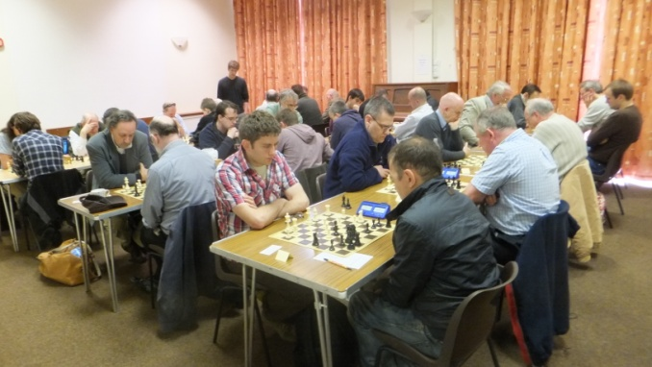
Round one in full swing

